B.Tech CSE – III Semester
Design and Analysis of Algorithms (DAA) Lab
Experiment 2 : Write a algorith for quick sort

Quick Sort Algorithm

How it works
Quick Sort is a divide-and-conquer algorithm that works as follows:
- Choose a pivot — pick an element from the array (commonly the last, first, or a random element).
- Partition — rearrange the array so that all elements smaller than the pivot come before it, and all elements greater come after it. After this step, the pivot is in its correct sorted position.
- Recurse — apply the same process to the sub-array of elements before the pivot, and separately to the sub-array of elements after the pivot.
- Base case — a sub-array with 0 or 1 elements is already sorted, so recursion stops.
Time complexity: O(n log n) average case, O(n²) worst case (e.g., already sorted array with a poor pivot choice)
Space complexity: O(log n) due to recursion stack

CODE-
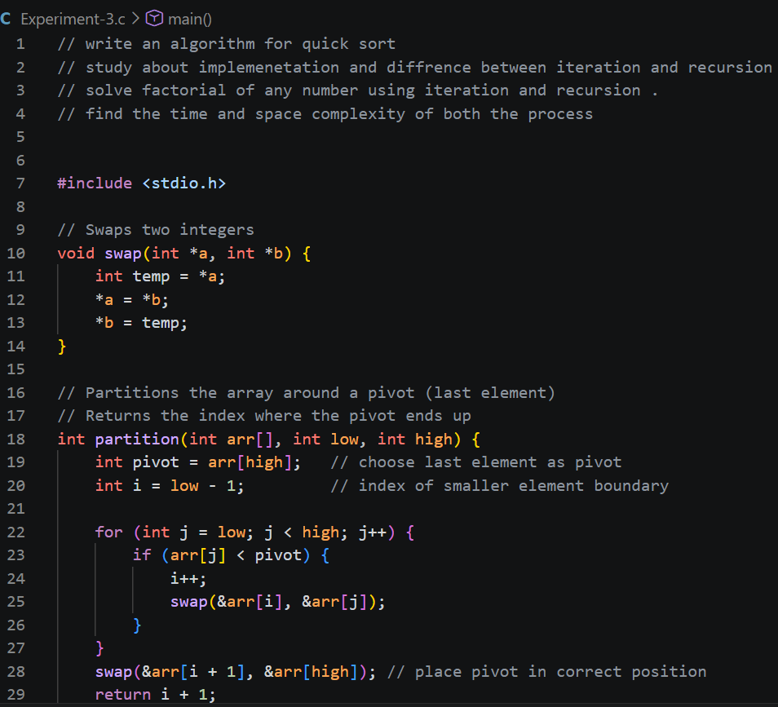

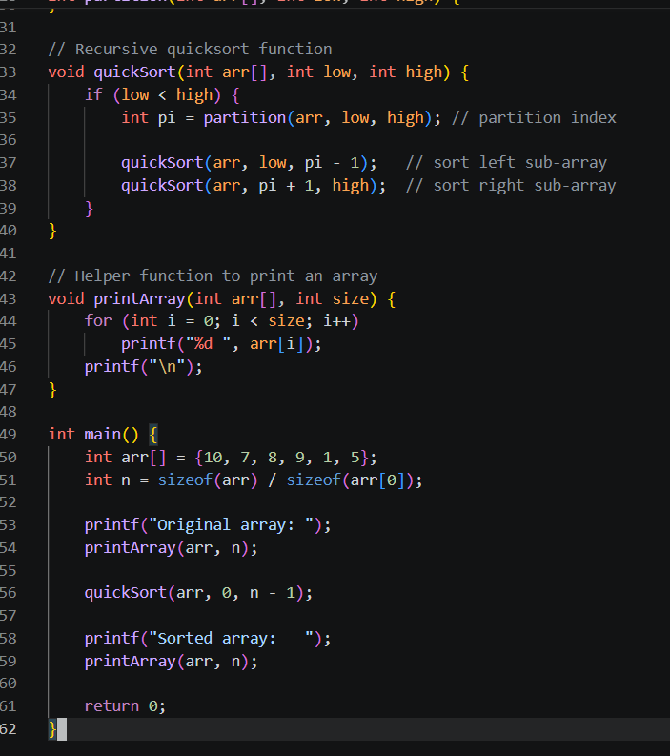

Output -
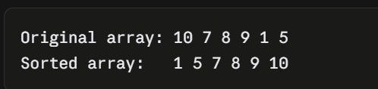

Study about implementation and difference between iteration and recursion

Iteration vs Recursion

Iteration
Iteration means repeating a block of code using loops (for, while, do-while) until a condition is met. The same variables are reused in each pass — no new function calls are made.
Example: Factorial using iteration

CODE-

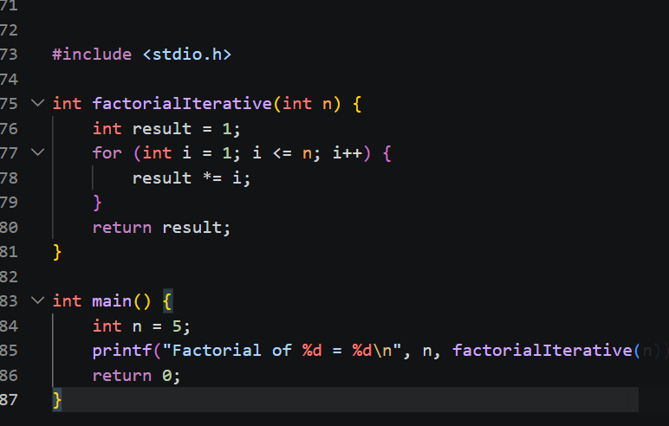

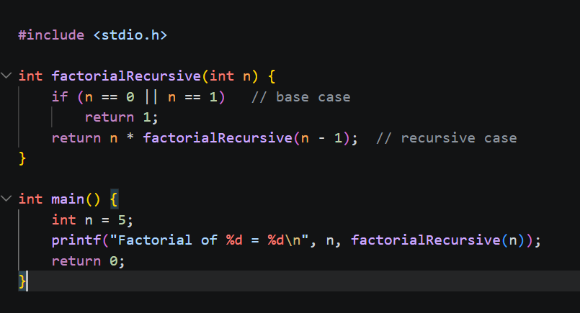

How each works internally
- Iteration: uses a loop counter/condition; memory usage stays constant (O(1) extra space) since no new frames are created.
- Recursion: each call is pushed onto the call stack with its own copy of local variables; when the base case is hit, the calls "unwind" and return values back up the chain. This needs O(n) space for n recursive calls (unless the compiler applies tail-call optimization, which C compilers don't guarantee).

Key Differences
Feature | Iteration | Recursion
Definition | Repeats a block of code using loops | Function calls itself to solve smaller subproblems
Termination | Loop condition becomes false | Base case is reached
Memory usage | O(1) — no extra stack frames | O(n) — one stack frame per call
Speed | Generally faster (no function call overhead) | Slower due to function call/return overhead
Code readability | Can get complex for problems like tree traversal | Often more elegant and closer to the mathematical definition (e.g., factorial, Fibonacci, Divide-and-Conquer algorithms)
Risk | Infinite loop if condition never fails | Stack overflow if base case is never reached or recursion is too deep
Use cases | Simple repetitive tasks (summing an array, printing a sequence) | Problems that are naturally recursive: tree/graph traversal, Divide-and-Conquer (Merge Sort, Quick Sort), backtracking
State | Explicit (loop variables) | Implicit (maintained via the call stack)

When to prefer which
- Use iteration when the problem is straightforward repetition and performance/memory matters (e.g., summing numbers, simple searches).
- Use recursion when the problem has a naturally recursive structure — like Divide-and-Conquer algorithms (Merge Sort, Quick Sort), tree/graph traversal, or backtracking — because the code closely mirrors the problem definition and is easier to reason about, even though it costs more memory.

Solve factorial of any number using iteration and recurtion ,
Find the time complexity and space complexity of both the process

Factorial: Iterative vs Recursive Approach

1. Iterative Approach

Algorithm
FACTORIAL_ITERATIVE(n)
1. result = 1
2. For i = 1 to n:
3. result = result * i
4. Return result

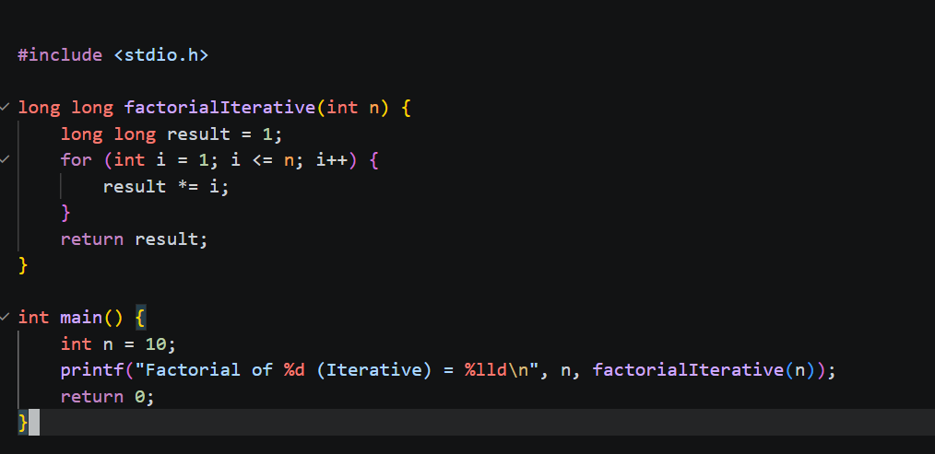

Complexity
- Time Complexity: O(n) — the loop runs exactly n times, doing one multiplication each time.
- Space Complexity: O(1) — only a fixed number of variables (result, i) are used, regardless of n. No extra memory grows with input size.

2. Recursive Approach

Algorithm
FACTORIAL_RECURSIVE(n)
1. If n == 0 or n == 1:
2. Return 1 // base case
3. Return n * FACTORIAL_RECURSIVE(n - 1) // recursive case

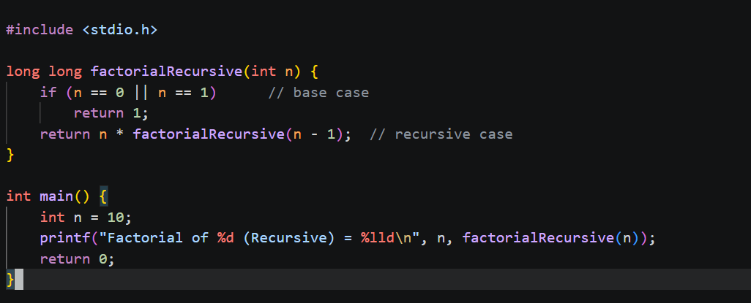

Complexity
- Time Complexity: O(n) — the recurrence relation is: T(n) = T(n-1) + O(1) Solving this gives T(n) = O(n), since the function makes exactly n recursive calls before hitting the base case.
- Space Complexity: O(n) — not O(1), because each recursive call adds a new stack frame to the call stack (storing n, the return address, and local state). These frames all stay on the stack simultaneously until the base case is reached and the calls start returning. So the maximum stack depth is n, giving O(n) auxiliary space.

